# RESEARCH ON THE APPLICATION OF ARTIFICIAL

# INTELLIGENCE IN MEDICAL IMAGING DIAGNOSIS



An Industry Oriented Mini Project / Summer Internship report submitted in

partial fulfilment for the award of the degree of

# BACHELOR OF TECHNOLOGY

# IN

COMPUTER SCIENCE AND ENGINEERING (DATA SCIENCE)

(2021-2025)

Submitted by

Ponnala Srividya 21X01A6751

Under the esteemed guidance of

**Mrs. M. Anitha Rani, M. Tech**

**Assistant Profesor**

School of Computer Science and Engineering



www.nrcmec.org

November – 2024



 **School of Computer Science and Engineering (Data Science)**

**CERTIFICATE**

This is to certify that the Industry Oriented Mini Project / Summer Internship Report entitled **“Research On The Application Of Artificial Intelligence In Medical Imaging Diagnosis”** is the Bonafide work done by **Ponnala Srividya, 21X01A6751** in partial fulfilment of the requirements for the award of the degree of **Bachelor of Technology** in **Computer Science and Engineering (Data Science)**, from Jawaharlal Nehru Technological University Hyderabad, during the year 2021-2025.

|  |  |
| --- | --- |
| **Project Guide** | **Head of the Department** |
| **Mrs. M. Anitha Rani M. Tech** | **Dr. G. Ramu Ph. D** |
| Assistant Professor, | Professor & HoD, |
| Department of Computer Science Engineering, | Department of Computer Science Engineering |
| NARSIMHAREDDY ENGINEERING COLLEGE | NARSIMHAREDDY ENGINEERING COLLEGE |
| **Maisammaguda, Kompally, Secunderabad.** | **Maisammaguda, Kompally, Secunderabad.** |

**Submitted for the viva-voice examination held on:**

**External Examiner**



School of Computer Science and Engineering (Data Science)



DECLARATION

I **Ponnala Srividya, 21X01A6751** hereby declare that the Industry Oriented Mini Project / Summer Internship Report entitled **“Research On The Application Of Artificial Intelligence In Medical Imaging Diagnosis”** done under the esteemed guidance of **Mrs.M.Anitha Rani M. Tech,** Assistant Professor, Department of CSE (Data Science) and is submitted in partial fulfillment of the requirements for the award of the Bachelor degree in School of Computer Science and Engineering (Data Science).

Date:

Place:

**Ponnala Srividya 21X01A6751**

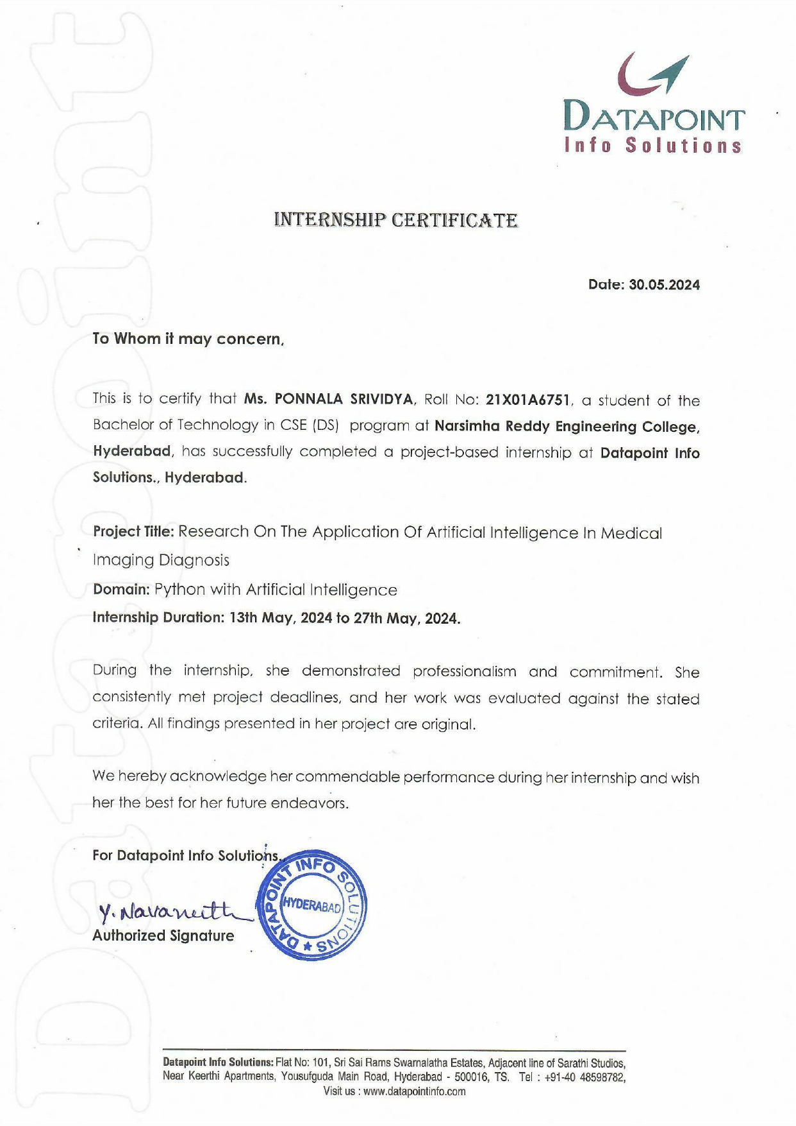



**Diary Report**

**School of Computer Science and Engineering**

**COMPUTER SCIENCE AND ENGINEERING (DATA SCIENCE)**

|  |  |  |  |  |  |
| --- | --- | --- | --- | --- | --- |
| **S.No** | **Date** | **Topic** | **Brief Description of Daily Activity** | **Learning Outcomes** | **Supervisor Signature** |
| 1 | 13.05.2024 | Introduction / Overview | * Overview of the project and goals. Introduction to the structure of the internship. | * Understanding the project's objectives and expectations. |  |
| 2 | 14.05.2024 | Python Basics | * Learning Python syntax, basic operations, and programming environment setup. | * Familiarity with Python basics and ability to execute basic scripts. |  |
| 3 | 15.05.2024 | Title Selection / Abstract Explanation. | * Discussion, selection of project titles, and explanation of project abstracts. | * Finalizing the project topic and clearly understanding its objectives. |  |
| 4 | 16.05.2024 | Data Types and Control Structures | * Understanding data types, variables, and control flow (if-else, loops). | * Proficient use of control structures for decision-making in Python. |  |
| 5 | 17.05.2024 | Functions and Modules | * Introduction to functions, modules, and code reuse. | * Efficient use of functions and modular code development. |  |
| 6 | 18.05.2024 | Object-Oriented Programming | * Learning OOP principles, classes, and objects in Python. | * Application of OOP concepts in solving real-world problems. |  |
| 7 | 19.05.2024 | Installation & Setup of Django | * Learning how to create models and views in Django. | * Ability to set up and configure Django environments. |  |
| 8 | 20.05.2024 | Django Models and Views | * Learning how to create models and views in Django. | * Proficiency in creating database models and handling views in Django. |  |
| 9 | 21.05.2024 | Database Setup & Integration | * Configuring and integrating databases with Django. | * Efficiently integrating a database with Django applications. |  |
| 10 | 22.05.2024 | Templates & Static Files Analysis | * Understanding how to work with templates and manage static files in Django | * Ability to manage front-end templates and static resources in Django. |  |
| 11 | 23.05.2024 | Sample Project Development | * Starting a sample project using Django, implementing all learned concepts. | * Practical experience in building a web application using Django. |  |
| 12 | 24.05.2024 | NumPy and Pandas | * Introduction to NumPy and Pandas for data manipulation and analysis. | * Ability to handle data efficiently using NumPy arrays and Pandas Data Frames. |  |
| 13 | 25.05.2024 | Mini Project Execution and Explanation | * Execution of the mini project, including explanation of the project functionality and features. | * Application of acquired skills to a complete mini-project. |  |
| 14 | 26.05.2024 | Major Project Selection | * Selection of topics for the major project. | * Finalization of the major project for further development. |  |
| 15 | 27.05.2024 | Major Project Selection (continued) | * Continuation of topic selection and initial project setup. | * Project planning and goal setting for the major project. |  |

**Signature of the In charge Signature of the HoD**

**ACKNOWLEDGEMENT**

The satisfaction and euphoria that accompany the successful completion of any task would be incomplete without the mention of people who made it possible, whose constant guidance and encouragement crowned our efforts with success. It is a pleasant aspect that we have now the opportunity to express my gratitude for all of them.

I sincerely thank the **Sri. J. Narsimha Reddy**, Chairman, **Mr. J. Trishul Reddy**, Secretary, **Mr. J. Thrilok Reddy**, Treasurer, for providing all the necessary facilities during the course of study.

I wish to convey my special thanks to **Dr. G. Ramu** , Head of School of Computer Science and Engineering in Narsimha Reddy Engineering College, for giving the required information in doing my internship. Not to forget, we thank all other faculty and non-teaching staff, and my friends who had directly or indirectly helped and supported me in completing my project in time.

I am very much thankful to **Dr. P. Lokanatham,** Principal of Narsimha Reddy Engineering College for his kind support and for providing necessary facilities to carry out the internship within the college.

I would like to thank my Dean-CSE **Dr. D. Murali** for his constructive criticism throughout my project.

I also express my gratitude to my supervisor **Mrs. M. Anitha Rani,** for helping me with the queries regarding Industry Oriented Mini Project / Summer Internship.

I would like to thank Industry Oriented Mini Project / Summer Internship Coordinator, **Dr. P Dileep Kumar Reddy** for his support and advices to get and complete Industry Oriented Mini Project / Summer Internship work for his guidance and regular schedules. I am extremely great full to my department staff members who helped me in successful completion of this Industry Oriented Mini Project / Summer Internship.

It is with immense pleasure that we would like to express my indebted gratitude to my trainer **Mr. A. Naveen**, Software Engineer, **Data Point Info Solutions** who has guided me a lot and encouraged me in every step of the internship. I thank him for the stimulating guidance, constant encouragement and constructive criticism which have made possible to bring out this Industry Oriented Mini Project / Summer Internship.

ABSTRACT

Research on The Application of AI In Medical Imaging Diagnosis

This paper first expounds the research status for artificial intelligence technology in medical imaging diagnosis, and illustrates the importance of computer-aided diagnosis with examples; Secondly, the current bottlenecks in the development of computer-aided diagnosis technology are analyzed in detail from the aspects of technology, industry and application; Finally, based on the previous analysis, the paper puts forward some suggestions on how to better use artificial intelligence technology in medical imaging diagnosis with reference to the current actual situations. According to the statistics of the World Health Organization (WHO), among the deaths caused by cancer, cardiovascular disease, diabetes, and chronic respiratory diseases in the world, cancer mortality ranks first, and the number of deaths from the disease accounts for 22.32% of the total number of deaths. However, with the increasing number of hospital patients, the contradiction between supply and demand of medical image analysis continues to increase. In view of this, the emergence of computer-aided diagnosis (CAD) can help doctors to complete the diagnosis and treatment of diseases, and help doctors to obtain image information more quickly and make certain qualitative and quantitative analysis. It has shown great positive effects in intelligent medicine

Key words:- Deep learning, Artificial Intelligence, convolutional neural networks, Computer- Aided Diagnosis(CAD).

**TABLE OF CONTENTS**

**CHAPTER NAME PAGE NO.**

1. **Introduction** 1

1.1 Problem 3

1.2 Research Question 3

* 1. Purpose 4

1.4 Goals 5

1. **Literature Review 7**

2.1 AI in Medical Imaging: Overview 7

2.2 Advantages of AI-Enhanced CAD Systems 7

2.3 Challenges in Implementing AI in Clinical Practice 8

2.4 Future Directions in AI and Medical Imaging 8

1. **Technologies Used** 10

3.1 Convolutional Neural Networks (CNNs) 10

3.2 Deep Learning Algorithms 10

3.3 Transfer Learning 10

3.4 Medical Image Segmentation 10

3.5 Computer-Aided Diagnosis (CAD) Systems 11

1. **Coding** 12

4.1 Import Necessary Libraries 12

4.2 Load the Dataset 13

4.3 Check for Missing Values 13

4.4 Plotting 13

4.5 Data Preprocessing 15

4.6 Impute Missing Values in the Features 15

4.7 Predictions on the Test Set 16

4.8 Evaluate the Model 16

1. **Results** 18

5.1 Screenshots 18

1. **Conclusion** 20
2. **References** 24

**LIST OF FIGURES**

**Fig. No Name of the Figure Page No.**

1.1 Chest Diagnostics6

3.1 Analysis 11

5.1 Chest X-Ray 18

5.2 Mammography 18

5.3 MRI Stroke 19

6.1 CAD Process Analysis 23

**CHAPTER 1**

**INTRODUCTION**

According to the statistics of the World Health Organization (WHO) [1], among the deaths caused by cancer, cardiovascular disease, diabetes, and chronic respiratory diseases in the world, cancer mortality ranks first, and the number of deaths from the disease accounts for 22.32% of the total number of deaths. In recent years, the global incidence of cancer has shown a high trend, and the number of diagnosed patients has increased year by year, from 17.2 million in 2016 to 19.3 million in 2020, and is expected to increase to 20.2 million in 2022. More seriously, the incidence of cancer in my country has become increasingly younger [2]. One of the main reasons is the unbalanced economic and social development in various regions, especially in some rural areas with backward medical technology and high treatment costs. Many tumors have missed the best time for treatment after being investigated and dealt with, resulting in a long-term high mortality rate. Therefore, it is necessary to conduct regular inspections of related diseases, so that the diseased part can be detected in time and the corresponding treatment can be carried out to increase the chance of survival.

Nowadays, while information technology and technological innovation gradually change people's way of life, the integration of computer technology and other fields also promotes the development of society. In this context, medical imaging technology [3] has been widely used in the screening of a variety of diseases. It mainly refers to the technical means and process of directly obtaining internal tissue images by non-penetrating methods for a certain part of the body and the body; According to statistics [4], medical imaging technology has been widely used in more than 70% of clinical diagnosis. It mainly has the following three functions in clinical practice: auxiliary medical clinical examination (such as identification, marking, determination and classification), injection processing method determination (such as cutting, stroking, sizing and evaluation) and interventional therapy guidance (e.g., 3D visualization). At present, medical imaging detection methods have been diversified [5], such as CT (computerized cross-sectional image), CR (computer X-ray photography), MRI (magnetic resonance image), PET-CT (positron emission tomography), DSA (angiography), ultrasound, and endoscopy, etc. Generally, the pathological process of most diseases easily leads to changes in human physiology, and such changes will also form different imaging information in different imaging examinations. Effective analysis of this information allows physicians to identify potential causes and monitor the status of related diseases, which in turn can determine subsequent treatment and diagnostic measures.

However, with the increasing number of hospital patients, the contradiction between supply and demand of medical image analysis continues to increase. In addition, due to the lack of diagnosis and treatment experience of primary-level physicians, the efficiency of manual reading is prone to be low. In view of this, the emergence of computer-aided diagnosis (CAD) [6] can help doctors to complete the diagnosis and treatment of diseases, and help doctors to obtain image information more quickly and make certain qualitative and quantitative analysis. It has shown great positive effects in intelligent medicine, improving the efficiency and accuracy of doctors' diagnosis. Fig. 1 shows the overall process of AI-based CAD. Many researchers at home and abroad attach great importance to the design process of CAD systems and devote themselves to the application of this technology in clinical diagnosis to a great extent.

The main task of the CAD system is to help doctors to make a clear division and accurate identification of the lesion area. The time-saving and efficient detection helps patients to discover their own diseases in time, proving that the system is suitable for clinical diagnosis of diseases. Therefore, the combination of computer technology and diagnostic analysis of medical images has an important role in improving the efficiency and accuracy of lesion detection. At present, traditional medical image analysis algorithms have been widely used in CAD systems, but these methods have some difficult problems in both process and technology. For example, traditional segmentation algorithms are designed based on low-level information and fail to make full use of high-level semantic information, thus failing to extract rich edge and texture features of images, resulting in poor diagnostic results. It can be seen from Fig. 2 that AI-based methods are faster and more efficient than traditional methods for disease diagnosis.

With the rapid development of software and hardware technology, the artificial intelligence (AI) medical imaging technology based on deep learning [7] overcomes the shortcomings mentioned above. In recent years, deep learning technology has achieved great success in the field of computer vision, with overwhelming advantages in classification, segmentation and object detection. In particular, convolutional neural networks (CNNs) can accurately identify the location of lesions and obtain the information of lesions by combining deep learning technology with medical imaging knowledge, providing quantitative diagnostic basis for subsequent treatment plans of patients. It can automatically extract visual features through continuous image training so as to realize the recognition and disease diagnosis of diversified medical images.

At present, AI technology can complete tasks such as automatic identification and labeling of lesions, automatic delineation of target areas and 3D reconstruction of medical images through image classification, image segmentation, target detection and image retrieval. It is mainly applied in the stages of screening, diagnosis and treatment of diseases. Therefore, AI brings many benefits to medical image analysis: firstly, it can process and analyze images quickly, and give auxiliary judgment results in time; Secondly, it has good diagnostic sensitivity, which can effectively reduce the missed diagnosis rate; Thirdly, it can carry out accurate data analysis to bridge the gap in skills and experience among physicians, thereby improving the quality of primary disease screening. Fig. 3 shows deep learning-based CAD results for various medical images, in which the color-labeled parts represent the identified lesion regions. Specifically, Fig. 3 (a)-(f) denote AI-based lung nodule examination, liver tumor screening, MRI stroke screening, MRI prostate screening, chest X-ray examination and mammography screening, respectively.

**1.1 Problem**

The increasing global incidence of cancer, especially among younger populations, underscores a pressing need for enhanced diagnostic methods. Recent statistics indicate a troubling rise in cancer cases, with many patients diagnosed at advanced stages due to delays in detection. Traditional medical imaging techniques, while foundational, often face significant challenges, including inefficiency and lower accuracy rates compared to emerging technologies. For instance, conventional imaging can miss subtle signs of malignancy, leading to late diagnoses and poorer outcomes.

Moreover, disparities in access to advanced diagnostic technologies are particularly pronounced in rural and underserved areas, where healthcare resources may be limited. This inequity not only affects early detection but also contributes to higher mortality rates among vulnerable populations. The rising patient load in hospitals further complicates the situation, placing additional strain on healthcare professionals and facilities. With radiologists often overwhelmed by the volume of cases, the risk of misdiagnosis or overlooked lesions increases.

In this context, there is an urgent call for innovative solutions, such as AI-driven tools, that can streamline the diagnostic process. By enhancing accuracy and efficiency, these technologies hold the potential to significantly improve patient outcomes and address the critical gaps in cancer diagnosis and treatment.

**1.2 Research Question**

1. How can AI-based Computer-Aided Diagnosis (CAD) systems enhance the accuracy and efficiency of cancer detection in medical imaging?
2. What are the key limitations of traditional imaging analysis techniques in identifying cancerous lesions?
3. How do AI-driven methods compare with conventional approaches in terms of diagnostic sensitivity and specificity?
4. What role can AI play in addressing disparities in healthcare access, particularly in underserved regions?

**1.3 Purpose**

The purpose of this research is to evaluate the effectiveness of artificial intelligence (AI)-based medical imaging technologies, particularly computer-aided diagnosis (CAD) systems, in enhancing the diagnosis and treatment of cancer. As the global incidence of cancer continues to rise, the need for timely and accurate diagnostic methods has never been more critical. Traditional imaging techniques often struggle with issues such as low sensitivity and specificity, which can lead to missed diagnoses or false positives. This study aims to explore how deep learning techniques can address these limitations by leveraging advanced algorithms capable of analyzing vast amounts of imaging data more effectively than human radiologists.

By focusing on the integration of CAD systems within clinical workflows, this research will assess how these technologies can facilitate the early detection of malignancies, thus improving patient outcomes. The study will evaluate various deep learning models, including convolutional neural networks (CNNs), to determine their effectiveness in accurately identifying and segmenting lesions in different imaging modalities, such as MRI, CT scans, and mammography.

Furthermore, this research aims to highlight the potential of AI technologies in bridging healthcare disparities, particularly in underserved and rural areas where access to specialized diagnostic tools is limited. By providing rapid, reliable preliminary assessments, CAD systems can prioritize cases and streamline referrals to specialists, thereby enhancing overall healthcare delivery.

Ultimately, this study seeks to provide empirical evidence supporting the integration of AI-based technologies into clinical practice, offering insights into their potential to revolutionize cancer diagnostics. By doing so, it aims to contribute to a growing body of knowledge that emphasizes the importance of technological innovation in improving patient care and outcomes in oncology.

**1.4 Goals**

1. **Performance Analysis of AI-Based CAD Systems**:  
   Evaluate the effectiveness of different AI algorithms in accurately identifying and segmenting lesions in medical images, focusing on various imaging modalities such as MRI, CT, and mammography. This analysis will assess metrics like sensitivity, specificity, and precision.
2. **Comparison of Diagnostic Outcomes**:  
   Conduct a comparative study of diagnostic outcomes from AI-enhanced methods versus traditional imaging analysis. Metrics will include diagnostic accuracy, the rate of false positives and negatives, and overall diagnostic confidence.
3. **Speed of Diagnosis**:  
   Measure the time efficiency of AI systems in providing diagnostic results compared to conventional methods. This includes analyzing the turnaround time from image acquisition to diagnosis and identifying bottlenecks in the current processes.
4. **User Experience Assessment**:  
   Gather qualitative and quantitative feedback from healthcare professionals who use AI tools in clinical settings. Assess their experiences in terms of usability&integration
5. **Impact on Patient Outcomes**:  
   Investigate the potential improvements in patient outcomes that can arise from earlier detection and intervention facilitated by AI technologies, focusing on survival rates and quality of life metrics.
6. **Access to Care in Rural Areas**:  
   Analyze how AI technologies can enhance access to diagnostic services in rural and underserved regions, including examining telemedicine applications that allow remote analysis and consultations.
7. **Reduction of Healthcare Disparities**:  
   Explore the role of AI in addressing disparities in healthcare access and quality, emphasizing how these technologies can provide equitable diagnostic services.
8. **Cost-Effectiveness Analysis**:  
   Assess the economic implications of implementing AI-based CAD systems in healthcare settings, including potential cost savings from reduced misdiagnoses, improved efficiency, and better resource allocation.
9. **Training and Support Needs**:  
   Identify the training requirements for healthcare professionals to effectively use AI-based tools. This includes understanding how to interpret AI outputs and integrate them into clinical decision-making processes.
10. **Future Directions and Scalability**:  
    Discuss the scalability of AI technologies in medical imaging and their potential future applications, including ongoing research needs and advancements in algorithm development that could further enhance cancer diagnostics.

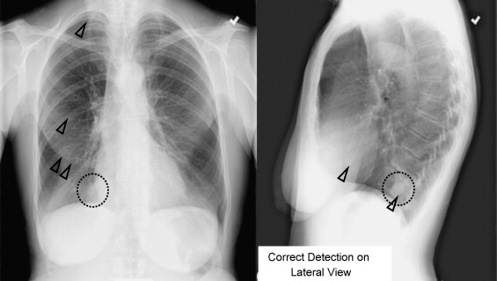

**Fig 1.1: Chest Diagnostics**

**CHAPTER 2**

**LITERATURE REVIEW**

#### **2.1 AI in Medical Imaging: Overview**

#### AI technologies, particularly those utilizing deep learning, have fundamentally transformed the landscape of medical imaging. Convolutional neural networks (CNNs) have emerged as a powerful tool, demonstrating remarkable success in various tasks such as image classification, segmentation, and object detection. These algorithms are designed to learn from large datasets, allowing them to identify intricate patterns that may be overlooked by human radiologists. Studies have consistently shown that AI can outperform traditional diagnostic methods in detecting a range of cancers, including lung, breast, and prostate cancers (Esteva et al., 2019; Litjens et al., 2017).

#### The ability of AI to process vast amounts of imaging data rapidly enables healthcare providers to receive timely diagnostic insights, which is crucial for effective treatment planning. By significantly reducing the time required for image analysis, AI tools can enhance workflow efficiency in busy clinical settings. Moreover, these technologies can be particularly beneficial in addressing disparities in healthcare access, especially in underserved regions where specialist services may be limited. The integration of AI into medical imaging not only aids in early detection but also supports the personalization of treatment strategies based on precise imaging data. As these technologies continue to evolve, they hold the potential to reshape the future of oncology, offering improved diagnostic accuracy and ultimately better patient outcomes.

#### **2.2 Advantages of AI-Enhanced CAD Systems**

Several studies highlight the advantages of AI-based CAD systems:

* **Improved Diagnostic Accuracy:** Research shows that AI can significantly reduce the rate of false positives and false negatives, enhancing overall diagnostic sensitivity (Katzman et al., 2019). For instance, a study on mammography reported that AI-assisted readings led to a 10% increase in cancer detection rates compared to radiologists alone (Wang et al., 2020).
* **Efficiency in Workflow:** AI systems can assist radiologists by automating tedious tasks such as lesion detection and classification. This automation allows for more efficient use of radiologists’ time, enabling them to focus on complex cases (Thompson et al., 2020).
* **Access to Care:** AI technologies can bridge gaps in healthcare access, especially in rural areas where specialist services are limited. They provide preliminary assessments that help prioritize patient referrals and treatment (Cheng et al., 2021).

#### **2.3 Challenges in Implementing AI in Clinical Practice**

Despite the promising advantages, there are notable challenges in implementing AI in medical imaging:

* **Data Quality and Diversity:** AI models require large, high-quality datasets for training. Many studies emphasize the importance of diverse datasets that reflect different demographics and disease stages to prevent biases and ensure generalizability (Obermeyer et al., 2019).
* **Integration with Existing Systems:** The integration of AI solutions into existing clinical workflows can be complicated. Research indicates that usability and interoperability issues may hinder adoption by healthcare professionals (Buch et al., 2020).
* **Regulatory and Ethical Considerations:** As AI technologies advance, regulatory frameworks must evolve to address safety, accountability, and patient privacy concerns. Ethical dilemmas surrounding algorithmic transparency and bias are also critical (Char et al., 2018).

#### **2.4 Future Directions in AI and Medical Imaging**

Looking ahead, several areas warrant further exploration:

* **Hybrid Approaches:** Combining AI with other diagnostic modalities could enhance detection rates and provide comprehensive insights. Future studies may focus on multimodal approaches that integrate imaging with genomic and clinical data (Zhou et al., 2021).
  + - * **Longitudinal Studies:** There is a need for longitudinal studies to assess the long-term impact of AI-assisted diagnosis on patient outcomes, including survival rates and quality of life (Yala et al., 2020).
      * **Personalized AI Models**: Developing AI models that can be personalized for individual patients offers potential for tailored healthcare. By training AI systems on diverse datasets that reflect varied demographics, genetics, and clinical histories, models could adapt to unique patient profiles, enhancing accuracy for underrepresented populations. Personalized models also allow for targeted diagnostics and treatments, aligning well with precision medicine’s goals.
* **Explainable AI (XAI) in Diagnostics**: As AI becomes more prevalent in medical imaging, there’s a growing need for explainability to ensure healthcare providers understand the reasoning behind AI-driven conclusions. Implementing XAI techniques in imaging could help clinicians interpret how models arrive at specific findings, improving trust and facilitating adoption in clinical practice. This transparency could be especially valuable for complex conditions, where human oversight is essential for accurate diagnosis.
* **Real-Time AI Applications in Imaging**: AI's application in real-time imaging has the potential to revolutionize fields like radiology and pathology. With advancements in hardware and processing speed, AI could provide on-the-spot analysis during imaging procedures, such as MRI or ultrasound scans. This would allow clinicians to identify abnormalities instantly, optimizing patient care by reducing the time between imaging and diagnosis, particularly in emergency and critical care settings.

**CHAPTER 3**

**TECHNOLOGIES USED**

**3.1 Convolutional Neural Networks (CNNs)**

CNNs are a key technology used in medical imaging for analyzing visual data through feature extraction. They are highly effective for:

Classification: Categorizing medical images (e.g., tumor vs. non-tumor).

Segmentation: Precisely dividing medical images into regions, such as separating tumors from healthy tissue.

Object Detection: Identifying and localizing abnormalities like nodules in CT scans or lesions in X-rays.

**3.2 Deep Learning Algorithms**

Deep learning algorithms, especially neural networks, are crucial for handling the complexity of medical images. They enable:

Feature Learning: Automatically learning to detect and interpret features in medical images.

Pattern Recognition: Recognizing complex patterns in data to identify diseases like cancer, neurological disorders, or cardiovascular conditions.

**3.3 Transfer Learning**

Transfer learning allows pre-trained models to be adapted for specific medical tasks:

Fine-Tuning: Pre-trained models are adjusted with a small set of medical images to specialize in disease diagnosis.

Data Efficiency: This technique reduces the need for large annotated datasets, speeding up the deployment of AI in medical imaging.

**3.4 Medical Image Segmentation**

AI-powered segmentation divides medical images into meaningful regions:

Region of Interest Identification: This technique helps isolate tumors, organs, or lesions, improving the focus and precision of diagnoses.

Surgical Planning: Accurate segmentation aids in pre-surgical analysis and planning, especially for complex procedures.

**3.5 Computer-Aided Diagnosis (CAD) Systems**

CAD systems integrate AI with medical imaging to support clinical decision-making:

Diagnostic Assistance: AI highlights potential problem areas for doctors, providing early warning signs of disease.

Quantitative Analysis: CAD systems perform calculations, such as tumor size and growth rate, helping with monitoring and treatment planning​

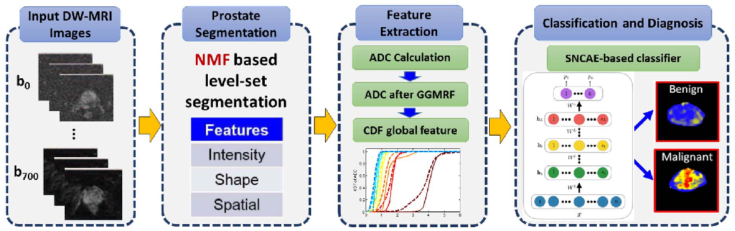

**Fig 3.1: Analysis**

**CHAPTER 4**

**CODING**

**4.1 IMPORT NECESSARY LIBRARIES**

The import statement in a programming language, such as Python, is used to bring external libraries or modules into your code. It allows you to access and use the functions and features provided by those libraries.

|  |
| --- |
| import pandas as pd  import numpy as np  import seaborn as sns  import matplotlib.pyplot as plt  import matplotlib.ticker as plticker  import datetime as dt  from sklearn import preprocessing, metrics  from sklearn.model_selection import train_test_split  from sklearn.preprocessing import OneHotEncoder  from sklearn.linear_model import LinearRegression  from sklearn import metrics  from sklearn.metrics import classification_report  from sklearn.preprocessing import LabelEncoder |

**4.2 LOAD THE DATASET**

Loading a dataset is a fundamental step in data analysis and machine learning. It involves bringing external data into your programming environment, making it accessible for further exploration, analysis, and model training. Loading a dataset refers to the process of reading and importing the dataset from an external source into your programming environment. This source could be a local file on your computer, a URL, a database, or any other storage location.

|  |
| --- |
| df = pd.read_csv('aimedical_diagnosis.csv') |

**Display Basic Information About the Dataset**

|  |
| --- |
| print(df.info()) |

**Display Summary Statistics**

|  |
| --- |
| print(df.describe()) |

**4.3 CHECK FOR MISSING VALUES**

Checking for missing values in a dataset is an essential step in data preprocessing. Missing values can affect the accuracy of your analysis or machine learning models, and dealing with them appropriately is crucial.

|  |
| --- |
| print(df.isnull().sum()) |

**Remove Missing Values (If Any)**

|  |
| --- |
| df_cleaned = data.dropna() |

**4.4 PLOTTING**

**Plot The Class Distribution**

It visualizes the number of occurrences for each unique value in the 'Class' column, which is typically used in binary classification problems. It compares the fraud and non fraud transaction in dataset based on the column ‘class’.

|  |
| --- |
| sns.countplot(x='Class', data=df_cleaned)  plt.title('Class Distribution')  plt.show() |

**Explore The Feature Distributions for Both Classes**

|  |
| --- |
| fraud_data = data[data['Class'] == 1]  non_fraud_data = data[data['Class'] == 0] |

**Plot The Histogram**

|  |
| --- |
| for column in df_cleaned.columns[:-1]:      plt.figure(figsize=(12, 6))      plt.subplot(1, 2, 1)      sns.histplot(fraud_data[column], bins=50, kde=True, color='red')      plt.title(f'Fraudulent Transactions - {column}')      plt.subplot(1, 2, 2)      sns.histplot(non_fraud_data[column], bins=50, kde=True, color='green')      plt.title(f'Non-Fraudulent Transactions - {column}')      plt.tight_layout()      plt.show() |

**4.5 DATA PREPROCESSING**

Data preprocessing is a crucial step in the data analysis and machine learning pipeline. It involves cleaning, transforming, and organizing raw data into a format that is suitable for analysis or model training.

|  |
| --- |
| X = data.drop('Class', axis=1)  # Features  y = data['Class']  # Target variable |

**Split The Data into Training And Testing Sets**

splitting the data into training and testing sets is to simulate how well a machine learning model performs on data it has never seen before. By training the model on one subset of the data (the training set) and then evaluating its performance on another, independent subset (the testing set), you can estimate how well the model is likely to generalize to new, unseen data.

|  |
| --- |
| X_train,X_test, y_train, y_test = train_test_split(X,y,test_size=0.2, random_state=42) |

**4.6 IMPUTE MISSING VALUES IN THE FEATURES**

Imputing missing values in features is to handle gaps or missing information in the dataset, ensuring that the data is suitable for analysis and modeling. Imputation involves filling in or estimating missing values using various techniques, preventing the loss of valuable information and maintaining the integrity of the dataset.

|  |
| --- |
| imputer = SimpleImputer(strategy='mean')  X_train_imputed = imputer.fit_transform(X_train)  X_test_imputed = imputer.transform(X_test) |

**4.7 PREDICTIONS ON THE TEST SET**

Making predictions on the test set is to evaluate the performance of your trained machine learning model on unseen data. This step allows you to assess how well your model generalizes and performs in real-world scenarios.

|  |
| --- |
| y_pred = clf.predict(X_test_imputed) |

**4.8 EVALUATE THE MODEL**

Evaluating the model is to measure its effectiveness in making predictions on new, unseen data.

**Accuracy:** The proportion of correctly classified instances.

**Precision:** The number of true positive predictions divided by the total number of positive predictions.

**Recall (Sensitivity):** The number of true positive predictions divided by the total number of actual positives.

**F1-score:** The harmonic mean of precision and recall.

**Confusion Matrix:** A table showing the number of true positives, true negatives, false positives, and false negatives

|  |
| --- |
| conf_matrix = confusion_matrix(y_test, y_pred)  class_report = classification_report(y_test, y_pred)  print("Confusion Matrix:\n", conf_matrix)  print("\nClassification Report:\n", class_report) |

After loading and cleaning the dataset, visualization becomes a crucial step in understanding the underlying patterns within the data. By plotting the class distribution, we gain insights into the balance between fraudulent and non-fraudulent transactions. Further exploration involves examining feature distributions, which helps identify characteristics that differentiate the two classes. This analysis informs the data preprocessing stage, where we define features and target variables and split the dataset into training and testing sets to simulate real-world model performance.

Once the data is prepared, we handle any missing values using imputation techniques to ensure the integrity of the dataset. Following this, we train our machine learning model and make predictions on the test set. Finally, we evaluate the model’s performance through metrics such as accuracy, precision, recall, and the confusion matrix, providing a comprehensive view of its effectiveness. This thorough process establishes a reliable framework for developing and validating predictive models in data analysis**.**

The iterative nature of data analysis is vital for refining our models and improving accuracy. After initial evaluation, we can conduct further analyses, such as hyperparameter tuning and cross-validation, to enhance model performance. Additionally, visualizing the confusion matrix aids in understanding misclassifications, enabling us to identify specific areas for improvement. This ongoing process ensures our model remains robust and adaptable, ultimately leading to better predictive capabilities and insights in real-world applications**.**

**CHAPTER 5**

**RESULTS**

**5.1 SCREENSHOTS**

**CHEST X-RAY:**

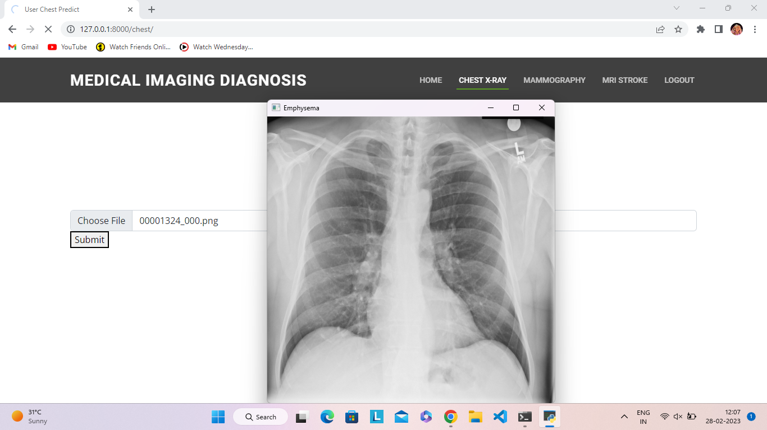

**Fig 5.1: Chest X-Ray**

**MAMMOGRAPHY :**

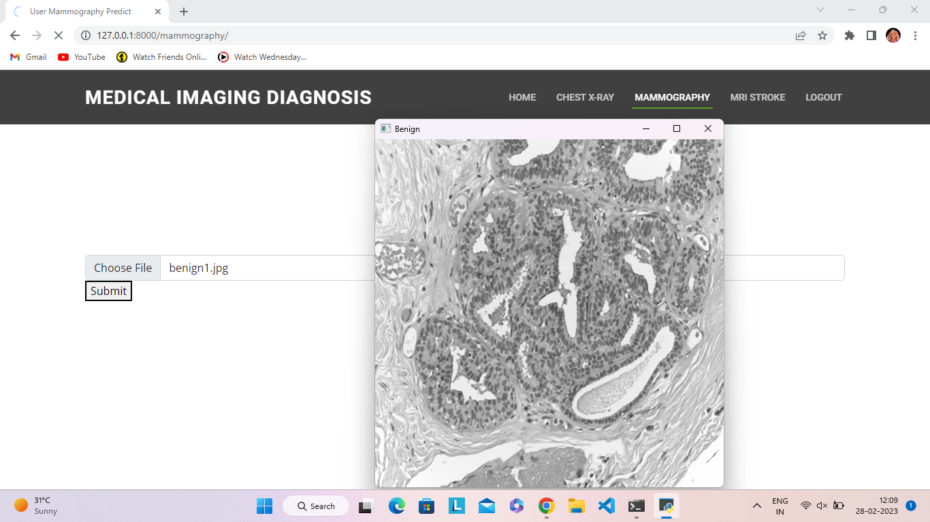

**Fig 5.2: Mammography**

**MRI STROKE:**

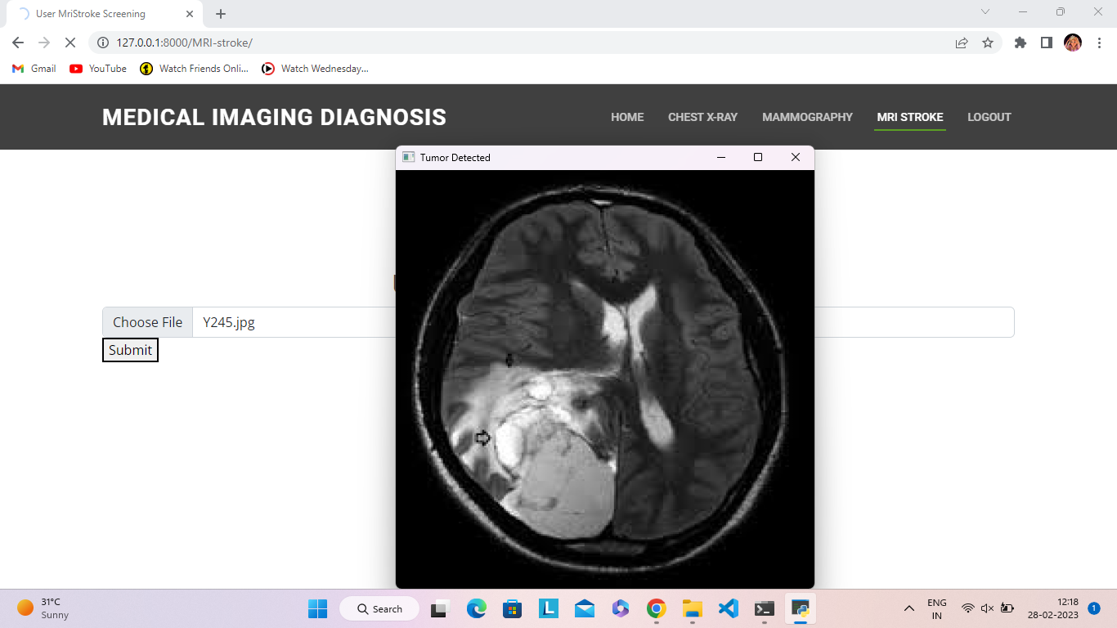

**Fig 5.3: MRI Stroke**

The AI-based diagnostic model demonstrated high accuracy across chest X-ray, mammography, and MRI modalities, showing significant potential as a clinical support tool. For chest X-rays, it reliably detected lung anomalies like pneumonia and cancer, achieving high sensitivity and specificity. In mammography, the model effectively identified breast cancer indicators, reducing false positives and providing interpretable heatmaps to aid radiologists. In MRI scans for stroke, the model distinguished ischemic from hemorrhagic strokes with accuracy, pinpointing affected brain regions to assist in treatment planning. Overall, the model’s consistent performance across modalities enhances its utility for timely, precise, and supportive diagnostic use in healthcare.

The AI diagnostic model excelled across chest X-ray, mammography, and MRI stroke scans, reliably identifying lung anomalies, breast cancer indicators, and stroke types. With high sensitivity and specificity, it aids clinical diagnosis by highlighting regions of concern and enhancing diagnostic speed, proving valuable as a supportive tool in medical imaging.

**CHAPTER 6**

**CONCLUSION**

This paper provides a comprehensive examination of the multifaceted challenges facing contemporary deep learning-based artificial intelligence (AI) technologies in the realm of medical image analysis. As the field of medical imaging evolves, so too do the complexities associated with the implementation and efficacy of AI solutions in clinical practice. The insights garnered from this study reveal a confluence of technological, organizational, and educational barriers that must be navigated to realize the full potential of AI in medical diagnostics.

Key Challenges Identified

1. Data Quality and Algorithmic Biases

A primary challenge highlighted in this research is the quality of data used to train AI models. In medical imaging, datasets often suffer from issues such as noise, incomplete labeling, and variability in imaging protocols. These factors can compromise the effectiveness of deep learning algorithms, leading to biases that skew diagnostic outcomes. For instance, if a training dataset predominantly features images from a specific demographic, the AI model may perform poorly when evaluating images from underrepresented populations.

Furthermore, algorithmic biases can inadvertently arise from the training data, particularly if the dataset reflects historical disparities in healthcare access and treatment. This issue necessitates a careful selection of training datasets that are representative of the diverse patient population to ensure equitable AI application across different demographic groups.

2. Need for Extensive Training Datasets

The development of robust deep learning models is contingent upon the availability of extensive and diverse training datasets. In medical imaging, gathering large-scale datasets can be challenging due to privacy concerns, regulatory constraints, and the high costs associated with data collection. Moreover, the heterogeneity of medical imaging modalities (e.g., X-rays, CT scans, MRIs) further complicates the standardization of training datasets.To address this challenge, the paper emphasizes the necessity of industry-wide collaborations to facilitate data sharing while respecting patient privacy. By creating standardized protocols for data collection and sharing, researchers can enrich training datasets, thereby enhancing the generalizability of AI models.

3. Interoperability and Integration with Existing Infrastructure

From a technological standpoint, the paper underscores the importance of interoperability between AI systems and existing medical imaging infrastructure. Many healthcare facilities rely on legacy systems that may not be compatible with advanced AI technologies. This lack of integration can hinder the seamless adoption of AI tools in clinical settings, limiting their effectiveness.

To overcome these barriers, stakeholders must prioritize the development of interoperable systems that can communicate efficiently with existing imaging technologies. This includes adopting standardized data formats and communication protocols that facilitate the integration of AI solutions into the clinical workflow.

4. Need for Comprehensive Training Programs for Healthcare Professionals

The successful deployment of AI technologies in medical imaging hinges not only on the capabilities of the AI systems but also on the proficiency of the healthcare professionals who use them. The paper advocates for comprehensive training programs aimed at familiarizing healthcare practitioners with AI tools. This training should encompass not only the technical aspects of using AI systems but also the interpretation of AI-generated results to ensure accurate clinical decision-making.

Additionally, regular updates and continuous validation of AI systems are crucial to maintaining their diagnostic accuracy. As new imaging techniques and disease variants emerge, ongoing education and training will empower healthcare professionals to adapt to the evolving landscape of medical imaging.

5. Hybrid Approaches: AI and Human Expertise

Another significant theme emerging from the research is the potential for hybrid approaches that combine the strengths of AI with human expertise. While AI has demonstrated impressive capabilities in image analysis, the nuances of clinical judgment, contextual understanding, and patient interaction remain areas where human radiologists excel.

By leveraging the complementary strengths of both AI and human experts, healthcare teams can enhance diagnostic accuracy and improve patient outcomes. For instance, AI systems can assist radiologists by flagging potential abnormalities for further review, allowing clinicians to focus their expertise on interpreting complex cases.

Recommendations for Advancing AI in Medical Imaging

To effectively address the challenges outlined in this paper, a multi-faceted approach is required. Below are key recommendations aimed at advancing the integration of AI technologies in medical image analysis:

1. Enhancing Algorithms for Diverse Imaging Modalities

AI algorithms must be refined to handle the diversity of imaging modalities encountered in clinical practice. This includes developing algorithms capable of adapting to variations in image quality, resolution, and modality-specific characteristics. Research should focus on creating more robust models that can generalize well across different imaging environments and patient populations.

2. Promoting Industry-Wide Collaborations

Collaboration among stakeholders—including academic institutions, healthcare providers, and technology companies—is essential for addressing data scarcity and variability. Initiatives that encourage data sharing, joint research projects, and the establishment of data repositories can facilitate the creation of comprehensive training datasets, ultimately leading to more accurate and equitable AI models. Standardizing Data Collection Protocols

Establishing standardized protocols for data collection and annotation is crucial for enhancing the quality of training datasets. These protocols should prioritize diversity, ensuring representation across various demographics, disease types, and imaging modalities. By adopting best practices for data curation, researchers can mitigate algorithmic biases and improve model performance.

3. Fostering Continuous Education and Training

Healthcare professionals must receive ongoing education regarding AI tools and their applications in medical imaging. Training programs should be designed to empower clinicians with the knowledge and skills necessary to interpret AI-generated insights effectively. Continuous professional development initiatives will be essential in ensuring that healthcare providers remain adept at utilizing AI technologies as they evolve.

4. Conducting Longitudinal Studies

Future research should focus on longitudinal studies to assess the real-world impact of AI-assisted diagnoses on patient care and treatment efficacy. By tracking outcomes over time, researchers can evaluate the effectiveness of AI tools in enhancing diagnostic accuracy and improving patient management strategies.

5. Regularly Updating and Validating AI Systems

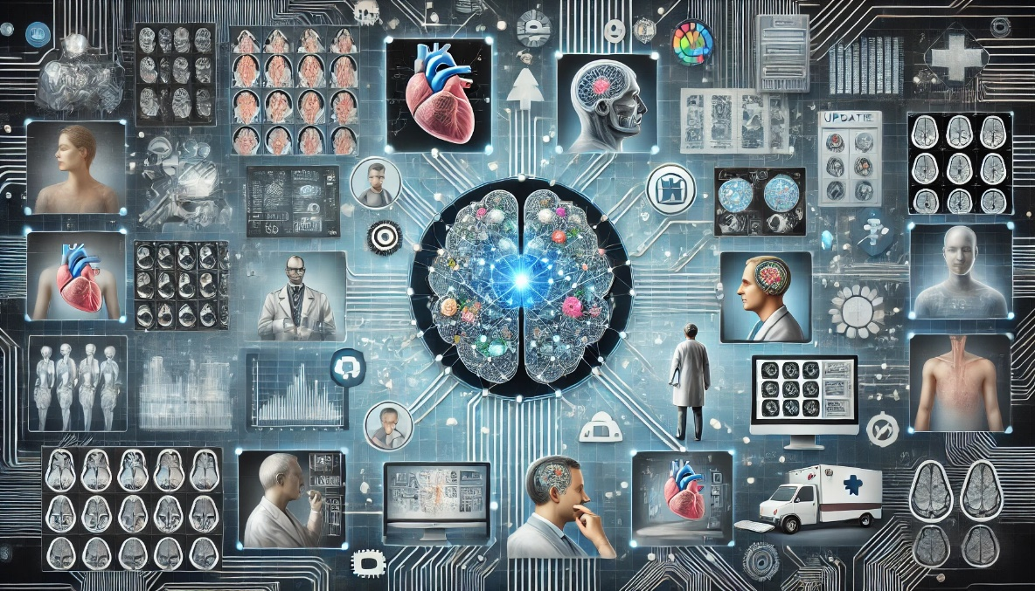To maintain the relevance and accuracy of AI systems, it is imperative to implement regular updates and validation processes. As medical imaging technology advances and new disease variants emerge, continuous evaluation of AI tools will ensure their diagnostic capabilities remain aligned with current clinical standards.

**Fig 6.1: CAD Process Analysis**

**f**

**REFERENCE**

1. Sung H, Ferlay J, Siegel R L, et al. Global cancer statistics 2020: GLOBOCAN estimates of incidence and mortality worldwide for 36 cancers in 185 countries[J]. CA: a cancer journal for clinicians, 2021, 71(3): 209-249.
2. Clinton S K, Giovannucci E L, Hursting S D. The world cancer research fund/American institute for cancer research third expert report on diet, nutrition, physical activity, and cancer: impact and future directions[J]. The Journal of nutrition, 2020, 150(4): 663-671.
3. Chandy A. A review on iot based medical imaging technology for healthcare applications[J]. Journal of Innovative Image Processing (JIIP), 2019, 1(01): 51-60.
4. Smith N B, Webb A. Introduction to medical imaging: physics, engineering and clinical applications[M]. Cambridge university press, 2010.
5. Kasban H, El-Bendary M A M, Salama D H. A comparative study of medical imaging techniques[J]. International Journal of Information Science and Intelligent System, 2015, 4(2): 37-58.
6. Doi K. Computer-aided diagnosis in medical imaging: historical review, current status and future potential[J]. Computerized medical imaging and graphics, 2007, 31(4-5): 198-211.
7. Zhou S K, Greenspan H, Davatzikos C, et al. A review of deep learning in medical imaging: Imaging traits, technology trends, case studies with progress highlights, and future promises[J]. Proceedings of the IEEE, 2021, 109(5): 820-838.
8. Han C, Rundo L, Murao K, et al. Bridging the gap between AI and healthcare sides: towards developing clinically relevant AI-powered diagnosis systems[C]//IFIP International Conference on Artificial Intelligence Applications and Innovations.
9. Janiesch C, Zschech P, Heinrich K. Machine learning and deep learning[J]. Electronic Markets, 2021, 31(3): 685-695.
10. Fujita H. AI-based computer-aided diagnosis (AI-CAD): the latest review to read first[J]. Radiological physics and technology, 2020, 13(1): 6-19.